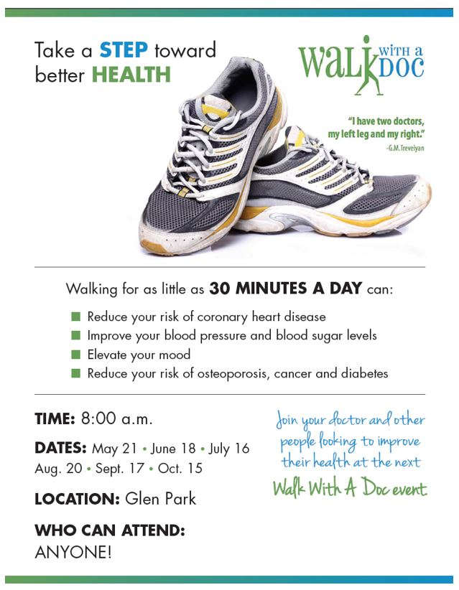**TIME:** Noon

**CONTACTS:**

Jessica Smith, RN Unity Point Health Trinity Regional Medical Center (515) 574-6187

Kim Drzycimski, RN

Iowa Heart Center Fort Dodge (515) 574-6167

**DATES:** Fourth Wednesday of each month

(May-October)

**LOCATION:** Unity Point Health-Trinity

Regional Medical Center

**WHO CAN ATTEND:** ANYONE!

*(This is a free event open to the public)*

**www.iowaheartfoundation.org**

