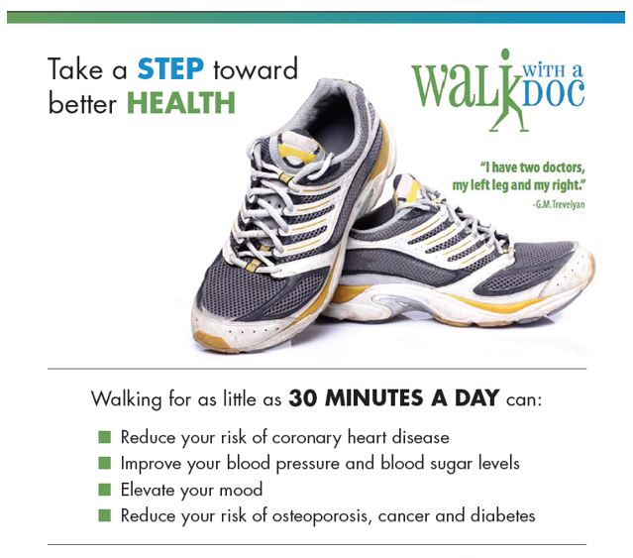
CONTACT:
Cindy Conroy Iowa Heart Foundation (515) 633-3555 cconroy@iowaheart.com

TIME: 5:30 p.m.
DATES: Fourth Wednesday of each month
(May-August)

LOCATION: St. Anthony Regional Hospital
Atrium

WHO CAN ATTEND: ANYONE!
(This is a free event open to the public)
www.iowaheartfoundation.org

